Alex Wiemels

12-6-21

Final Game Documentation

Game Design Document – My game is set in space with the player piloting a spaceship that is tasked with defending earth from aliens. The goal of the game is the kill aliens to get a higher score, if the player doesn’t kill an alien it will travel off the bottom of the screen and cause the player to lose one life. If the player loses all his lives, then the game ends. The game was written in Python specifically with the Pygame library, the game only has five sprites. The star sprite is simply a small white square which is blitted multiple times to the screen at random spots and travel down the screen to create the effect of stars flying by as your spaceship travels by, when they travel off the bottom of the screen they loop back to the top of the screen at a random horizontal position. The laser sprite is simply a small red rectangle sprite that acts as the players main form of attack. It travels up the screen until it reaches an enemy or leaves the screen. When the laser gets within a certain distance from an alien sprite, both sprites are placed off screen. The heart sprite is a red heart sprite that is used to represent the players health it is constantly in the bottom left part of the screen. The spaceship sprite is what the player controls it can move left and right within the confines of the screen but not leave it. The spaceship will fire a laser when the spacebar is pressed. The laser is blitted to the top middle of the spaceship sprite and progress straight up from where it was originally blitted until it leaves the screen. The alien sprite will be blitted off screen and the move downward from there. If the alien reaches the bottom of the screen it is then placed back at the top and decreases the health value of the player.

Software Engineering Plan – I worked individually on this project, so I did the programming, and the writing of the documentation alone. As for the timeline of the project, I did most of the programming for the game during the weekend spanning the 4th to the 5th and wrote the documentation for the project on the 6th of December.

State Transition Diagram –

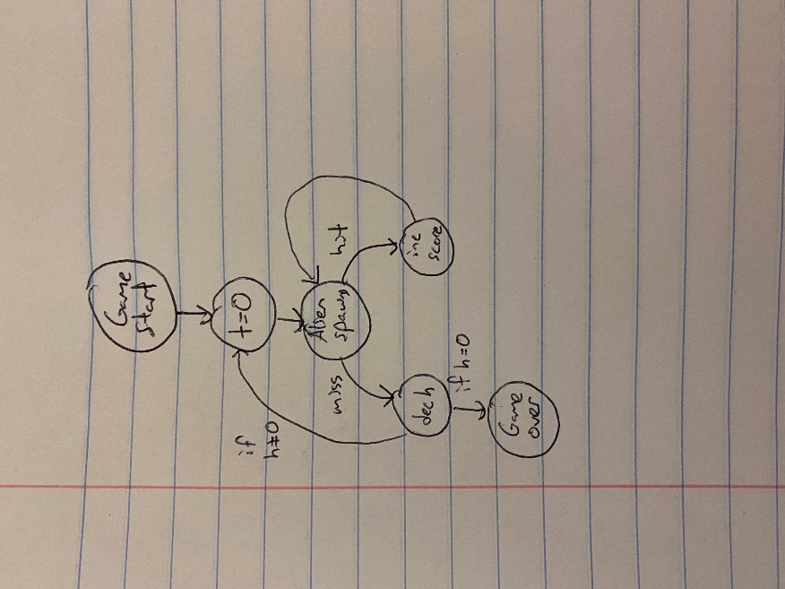

User Instructions – the game is very simple and there are only three buttons the player will need to press over the course of the game. The left and right arrow keys will move the spaceship left and right respective, the spaceship can’t leave the edge of the screen. So, it will stop a little bit away from that edge. Pressing the spacebar will fire a laser from the front of the ship which will travel straight up the screen. While the laser is on screen, the player can’t fire another laser. Once the laser either leaves the screen or hits the alien then the player can fire another laser. The player has three lives, the player loses a life if an alien manages to get past the player and leave the screen. Once the player loses all three lives the game ends. The players goal is to get the highest score they can, which is displayed in the top left part of the screen.